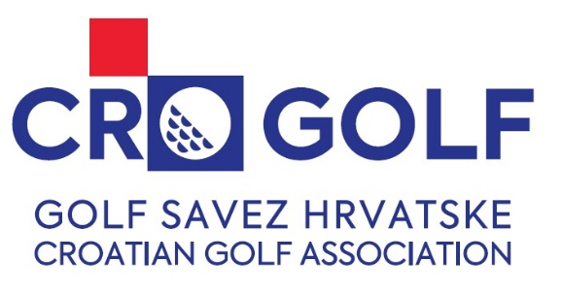
CROATIA OPEN 2026
34th Croatian International Amateur Championship


Riverside Golf Zagreb
5th – 7th June 2026

ENTRY FORM

Nationality:
Last Name:
First Name:
Gender:
Date of Birth:
(DD/MM/YEAR)
Gsm for contact:
Email:
Home Club:
Handicap:
(+ = below 0)
Date:
(DD/MM/YEAR)
Signature of Applicant:
Handicap and Amateur Status of the above player are hereby confirmed by golf federation / association:
Date
(DD/MM/YEAR)
Entry Form please send on: ured@golfsavez.hr

